**[Chef Francesca Simoni](http://www.jeddahfood.com/chef-francesca-simoni/)**[**FoodCritic**](http://www.jeddahfood.com/members/foodcritic/)

3

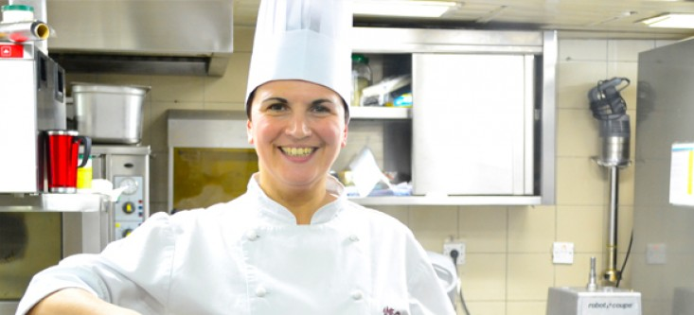

Chef Francesca Simoni is flying into Saudi Arabia from Bologna, Italy to oversee the third edition of the [Italian Food Festival](http://www.jeddahfood.com/italian-festival-rosewood/), taking place in Habsburg restaurant in Rosewood Corniche Jeddah from 15 to 30 January 2014.

Chef Francesca is the Executive Sous Chef at Amerigo 1934 Trattoria, the winner of the prestigious Gambero Rosso Award for the best restaurant in Italy in 2013.

Amerigo 1934 Trattoria has supplied the team at Habsburg with the finest ingredients needed for the Italian Food Festival menu, including extra virgin olive oil to authentic cheese selections and pasta varieties.

Diners at the Italian Food Festival will be treated to a variety of exquisite cuisine from the Emilia-Romagna region of Italy, including authentic homemade pasta, fresh seafood Fritto Misto, as well as a spectacular live risotto cooking station.

We managed to track Chef Francesca down to ask a few questions about the forthcoming event and find out a little more about herself and her passion for fine food.

**This is the third Italian Food Festival at Rosewood Corniche, and you are the first female Italian chef to take part. Are you excited to be participating?**

Absolutely! This my first experience in the Middle East, and to start it at the heart of the Arabian Peninsula makes it an even more meaningful journey. I cannot wait to meet the Italian Food Festival guests at Rosewood Corniche.

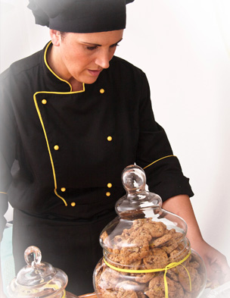

**We’ve heard that the Festival menu will bring flavours of Emilia-Romagna to Jeddah. Can you tell us a little more about this famous food region in Italy?**

Emilia-Romagna is considered the heart of Northern Italian food and features delicacies such as prosciutto, Parmigiano Reggiano cheese, and freshly made pasta.  And it has a reputation for incomparable balsamic vinegar.

Pasta is Emilia-Romagna’s speciality. From the popular lasagna and cannelloni to tortellini, Cappelletti and Risotto, the region is known for flavouring pasta dishes with different sauces made with tomatoes, radicchio, prosciutto or fresh mushrooms. Tomato sauces are perhaps the favourite accompaniment to pasta in this region.  
The famous meat sauce typical of the Bologna area known in Italy as ragu, is known to most as Bolognese Sauce.

**How did you get to where you are today? Can you tell us a bit about your professional experience and career path? And what inspired you to start cooking professionally?**

Since I was a child, I used to enter the kitchen with my mother and grandmother and watch them cooking for hours. A few years later, I started helping them in preparing the authentic dishes of Emilia-Romagna for our family and guests.  
This is what inspired me to take a further step and attend Cooking College in Bologna, where I learned the essentials of Italian and international cooking.

After my graduation, I worked in different restaurants in the same region, and I learnt how to make classic Italian pastry. I have a great passion for sweets.

I am now working as an Executive Sous Chef at Amerigo 1934 Trattoria and have been here for the last seven years ago.

**Chances are there are many readers here that would probably like to start cooking professionally, what advice would you give to them?**

Passion is the basis of every successful career. If you are passionate about cooking, there is nothing better than making it a profession. Succeeding in a cooking career also requires a lot of commitment, patience, and hard work.

[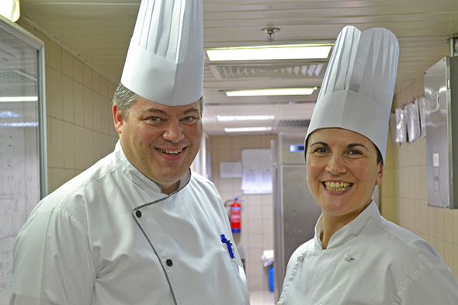](http://www.jeddahfood.com/wp-content/uploads/2014/01/duo.jpg)

Chef Maurizio Panicali and Chef Francesca Simoni

**Do you have a favourite Italian dish?**

This is a hard question, but I would say that all kinds of authentic homemade pasta are irresistible, I love them all!

**This is your first visit to Jeddah and the Kingdom, what are your first impressions? Have you sampled any of the local cuisine?**

I was impressed by the hospitality and diversity of the Arab culture, people here are very welcoming and open to others.The Saudi cuisine is one of the richest in the region, I have read about it but it is nothing like trying it.  
I am discovering new dishes every day and I can only say that it is one of the tastiest and most unique cuisines in the world.

**What is the biggest challenge cooking for so many people in a restaurant?**

The whole experience is a big challenge, but I would say the core of it is to satisfy every single guest in the restaurant and make them feel special as if the chef spent all the time taking care of their meal and only theirs.

**Are there any trends in cooking that have emerged in the last few years that you think we should keep an eye on?**

Cooking trends have been developed since the beginning of humanity. Every day brings a new invention, a new technology that makes cooking easier, tastier, and more enjoyable.

The diversity of cultural backgrounds is also reflected in cooking trends. To make the best of the whole movement, one should read, watch the news, and especially pick up what they need and do not buy things for the sake of following the trend.

**Can you recommend any dishes we should look out for at the Italian Food Festival at Rosewood Corniche?**

I would recommend all dishes without exception! We have prepared a diversified menu of authentic Italian cuisine that will certainly dazzle Rosewood Corniche guests. I am so looking forward receiving them all at Habsburg and sharing the Italian culture with them.

**If there was one ingredient you would recommend to spice up a bland dish in a kitchen, what would it be?**

I love Fresh basil it gives such a unique taste to cold or hot dishes, it has a very unique flavour it’s difficult to explain it is peppery, sweet menthol like flavour!

*Thanks so much for your time!*

Jeddah Food Team

- See more at: http://www.jeddahfood.com/chef-francesca-simoni/#sthash.qRKuzU5j.dpuf