

**Italian Food Festival at Rosewood Jeddah** Tuesday 6 January 2015

﻿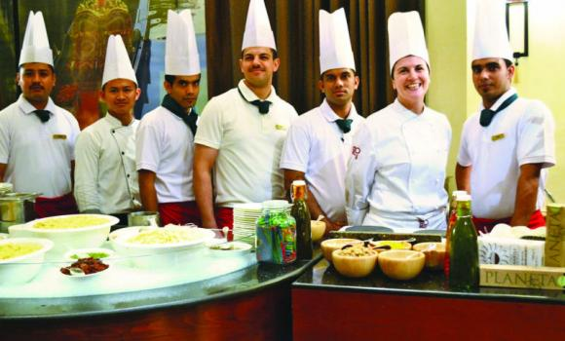

Rosewood Jeddah is wrapping up preparations for one of the most exciting culinary festivals in the city, the Italian Food Festival, taking place from Jan. 14 to 28 .  
Returning for the fourth time at the hotel’s popular Habsburg restaurant, the Italian Food Festival will feature the best of Italian cuisine, offering hotel guests a true culinary experience from one of the country’s most well-known food regions, Emilia Romagna.  
Talented culinary expert, Chef Francesca Simoni from Bologna, Italy, is also confirmed to return to Rosewood Jeddah to treat diners to the deliciously fresh, innovative cuisine throughout the festival.  
Joining Simoni will be Rosewood’s new Executive Chef, Amjad Yousef Al Ghandoor, who will help bring the authentic flavours of Italy to Jeddah, the Bride of the Red Sea.  
“Last year I was the first female Italian Chef taking part in a leading festivity in Jeddah,” said Chef Francesca.   
“It is such a privilege and honor to return to the Kingdom for my second experience here and I am thrilled to be back after the overwhelming success of last year’s event.  
“I have been blessed with a professional and skilled team at Habsburg and I am certain this year’s festival will surpass expectations. We have prepared a diverse and rich menu for our guests including specialties from my native Bologna where we’re famous for our fresh and delicious cuisine.”  
Diners can expect a variety of cuisine favorites at the festival, including Chef Francesca’s specialities, ravioli and homemade pasta, fresh seafood Fritto Misto and live cooking stations offering Habsburg guest’s mouth-watering dishes.  
Hans-Peter Leitzke, managing director at Rosewood Jeddah, said: “The idea behind the Italian Food Festival is to bring one of the world’s favorite cuisines to our valued guests and treat them to a true Italian dining experience right here in Jeddah.”  
He said: “Last year’s Festival was such a success we knew we had to bring Chef Francesca Simoni back. We predict this year’s festival to be bigger and better as Jeddah foodies could not get enough of the delicious dishes that Chef Francesca prepared. This year she also has our very own talented Chef Amjad to be her right hand man in the kitchen.”  
The two-week event is hosted by the team at Habsburg restaurant, and sponsored by The First Group, Acqua Panna, Alam Arrajul Magazine, Arab News and Platinum Magazine.  
Those eager to experience a taste of Italy will be able to dine each evening from 7:00 p.m. to midnight throughout the festival for SR210 per person, including mineral water and soft drink.



**Rosewood Jeddah’s Italian food fest is bigger and better** Wednesday 21 January 2015

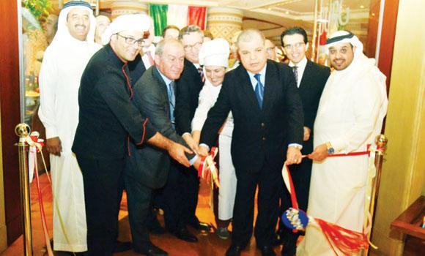

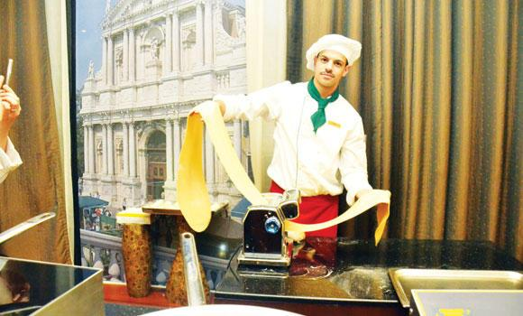

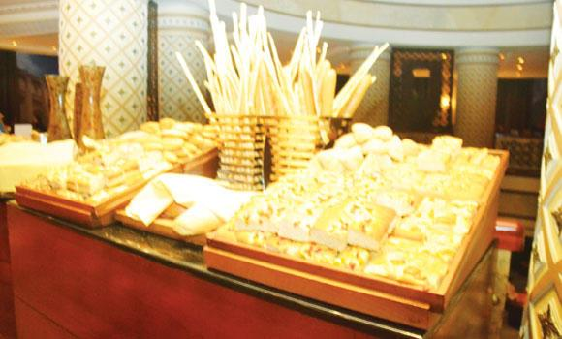

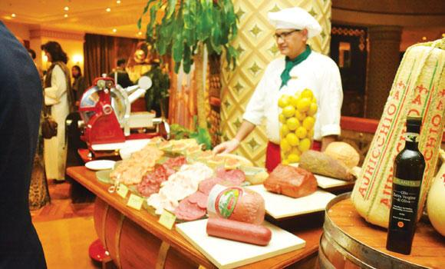

The fourth edition of the Italian Food Festival at Rosewood Jeddah was launched last week. Chef Francesca Simoni from Bologna and executive chef Amjad Yousef Al-Ghandoor are presenting traditional Italian cuisine from across Italy with a unique modern touch at Habsburg, a Rosewood restaurant.  
Chef Francesca is the Executive Sous Chef at Amerigo 1934 Trattoria, the winner of the prestigious Gambero Rosso Award for the best restaurant in Italy in 2013. She flew into Jeddah especially for the festival. Together with Al-Ghandoor, she is preparing authentic dishes not only from her region, Emilia-Romagna, but from all the major Italian cities. The festival will continue until Jan. 28.  
Chef Al-Ghandoor has more than 15 years’ international culinary experience and has worked with high profile hotel chains across the world. He said his speciality comprises using local ingredients and presenting them with a modern twist.  
“For this year’s Italian Food Festival we created a unique menu comprising traditional dishes from Italy, but with a different and unique touch. Lots of ingredients such as Parmesan cheese, fresh trifle, different kinds of teas, smoked meats and fish, etc., especially flew in from Italy,” he said.  
Some of the speciality items on the list include traditional homemade pasta comprising eggs, bread crumbs, and flour, usually served with prawns, olive oil, and aromatic herbs; fresh pizza, risotto, focaccia with coarse salt and rosemary, potato bread, focaccia with onion bread, polenta bread, plain olives vertes bread, ricotta bread focaccia with frigitelli, rustic Italian bread, “Tigelle” bread, fried “Crescentine” bread, tagliatelle with white meat ragù and black trifles and salad.  
“The hot items on the menu are chicken and meat served with different kinds of sauces, ingredients, and incorporating different methods of cooking. The spread is divided into four menus; there’s also fusion of two different cuisines as desserts will have an oriental flavor to them,” chef Al-Ghandoor said.   
Chef Francesca told Arab News that she is extremely happy to be back and to share her experience once again with the people of Jeddah. “It’s wonderful to come back as I was welcomed very warmly. Last year, we presented 60 recipes and this year we introduced many more new and different dishes,” she said.  
Examples of new and unique dishes include fresh risotto made with black trifles and mushrooms, traditional pasta made with eggs, bread crumbs, Parmesan cheese, flour and a white meat ragout with tomato sauce.  
“Some traditional breads, in particular tigella, which is cooked in a special device made with cast iron, are presented with salami, baked chicken and fish; also on the menu are delicious baked goods such as bread with tomato, bread with capsicum and black olives,” she said. These are prepared with béchamel sauce, Parmesan cheese, Parmesan cheese ice cream and a drop of balsamic vinegar — a must try.  
The festival has much more to offer, including delicious risottos, pastas, pizzas served with tomato-based or cream-based sauces, seafood, meat and chicken dishes, the cheese being a recurring addition to all dishes.  
Diners can expect a variety of cuisine favorites at the festival, including Chef Francesca’s specialties, ravioli and homemade pasta, fresh seafood FrittoMisto and live cooking stations offering Habsburg guests’ mouth-watering dishes.  
While guests are free to eat whatever — and in whichever order — they feel like, those who wish to dine the Italian way can start off with some salad, or antipasti in Italian.  
The Caprese salad in a cup, a combination of pureed tomatoes and pureed mozzarella cheese topped with some pesto and basil, is a treat that will set the right tone for the rest of the evening.  
Consequently, Italians eat their primo — usually pasta, but risotto, gnocchi or soup is also possible.  
A live cooking station produces some of the best tasting preparations of pasta, risotto, and pizza, bruschetta, Italian bresaola, beef salami, smoked turkey breast salami, and toasted bread with olive oil, fresh garlic and tomatoes.  
Zucchini and saffron risotto, Parmesan cheese and balsamic vinegar risotto, lasagna with vegetables and pesto sauce, tagliatelle with white meat ragù and black trifles are other delicacies on offer.  
Simoni especially recommends the tagliatelle with white meat ragù and black trifles.  
The main dish consists of fish or meat, but vegetarians can opt for grilled vegetables.  
Some of the best main course items include sea bass “Acqua Pazza”, lemon scallops with carrot, grilled tiger shrimps, lamb with artichoke, beef tenderloin “tagliata” with black trifles and chicken with parmesan milk sauce and stuffed capsicum.  
There is an amazing variety of desserts too. This year, the main desserts are a combination of Italian and French cuisines: chocolate salami; rice tort, fresh fruit torte, ricotta cake with strawberry, best shortbread cookie, Italian apple pie, a selection of cut fruit, Umm Ali and Arabic sweets.  
Chocolate salami might sound gross, but luckily, it does not consist any salami. It combines chocolate, biscuit, and almonds in a salami-shaped roll.  
Rice tort is another sweet dish that diners must try.  
Those eager to experience a taste of Italy will be able to dine each evening from 7:00 p.m. to midnight throughout the festival for SR 210 per person, including mineral water and soft drinks.